==================================================

Running Genetic Algorithm with HistGradientBoosting...

==================================================

==================================================

=== GENETIC ALGORITHM OPTIMIZATION ===

==================================================

[Initialization]

- Population size: 30

- Generations: 20

- Crossover rate: 80%

- Mutation rate: 20%

- Search space: 14 features

- Target: Minimize MSE using HistGradientBoosting

[Evolution Progress]

Gen 01/20 | Best MSE: 0.495699 | Avg MSE: 0.503606

Gen 06/20 | Best MSE: 0.492987 | Avg MSE: 0.492987

Gen 11/20 | Best MSE: 0.491578 | Avg MSE: 0.491956

Gen 16/20 | Best MSE: 0.491578 | Avg MSE: 0.491579

Gen 20/20 | Best MSE: 0.491578 | Avg MSE: 0.491578

==================================================

=== OPTIMIZATION RESULTS ===

==================================================

▶ Best MSE achieved: 0.491578

▶ Time elapsed: 670.68 seconds

▶ Features selected: 14/14 (0.0% reduction)

▶ Selected features:

1. 0

2. 1

3. 2

4. 3

5. 4

6. 5

7. 6

8. 7

9. 8

10. 9

11. 10

12. 11

13. 12

14. 13

▶ Convergence progress:

- Initial MSE: 0.4957

- Final MSE: 0.4916

- Improvement: 0.8%

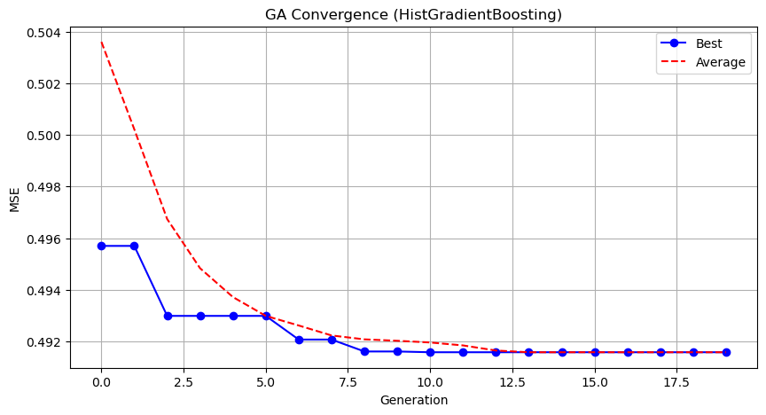

Genetic Algorithm completed successfully with MSE: 0.4916

==================================================

Running Particle Swarm Optimization with HistGradientBoosting...

==================================================

==================================================

=== PARTICLE SWARM OPTIMIZATION ===

==================================================

[Initialization]

- Swarm size: 30 particles

- Iterations: 20

- Cognitive weight: 0.5

- Social weight: 0.5

- Inertia weight: 0.5

- Search space: 14 features

- Target: Minimize MSE using HistGradientBoosting

==================================================

=== OPTIMIZATION RESULTS ===

==================================================

▶ Best MSE achieved: 0.491608

▶ Time elapsed: 620.44 seconds

▶ Features selected: 13/14 (7.1% reduction)

▶ Selected features (with weights):

1. 0 (weight: 0.532)

2. 1 (weight: 0.903)

3. 2 (weight: 0.777)

4. 3 (weight: 0.625)

5. 4 (weight: 0.587)

6. 5 (weight: 0.529)

7. 6 (weight: 0.878)

8. 8 (weight: 1.000)

9. 9 (weight: 0.727)

10. 10 (weight: 0.567)

11. 11 (weight: 0.531)

12. 12 (weight: 0.636)

13. 13 (weight: 0.823)

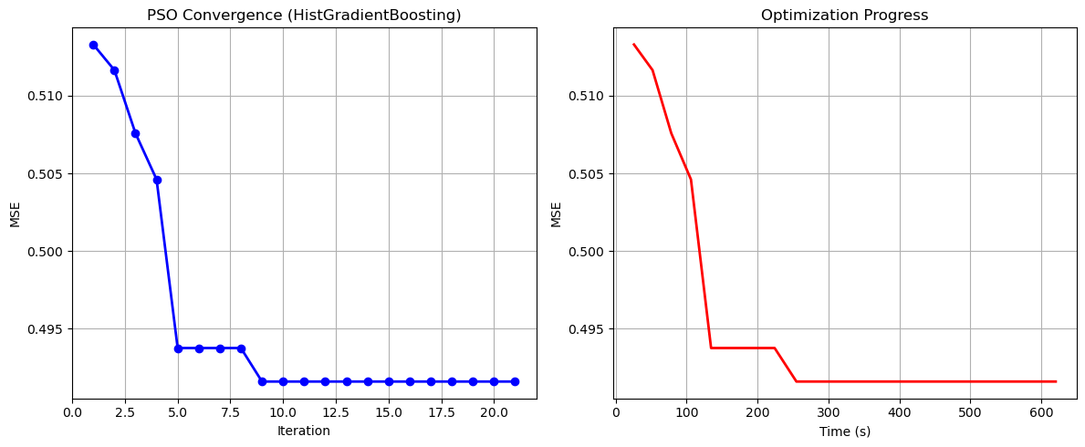

Particle Swarm Optimization completed successfully with MSE: 0.4916

==================================================

Running Whale Optimization with HistGradientBoosting...

==================================================

==================================================

=== WHALE OPTIMIZATION ALGORITHM ===

==================================================

[Initialization]

- Population: 30 whales

- Max iterations: 20

- Spiral coefficient (b): 1.0

- Search space: 14 features

- Target: Minimize MSE using HistGradientBoosting

[Optimization Progress]

Iter 20/20 | Best MSE: 0.491578

==================================================

=== OPTIMIZATION RESULTS ===

==================================================

▶ Best MSE achieved: 0.491578

▶ Time elapsed: 657.60 seconds

▶ Features selected: 14/14 (0.0% reduction)

▶ Selected features:

1. 0

2. 1

3. 2

4. 3

5. 4

6. 5

7. 6

8. 7

9. 8

10. 9

11. 10

12. 11

13. 12

14. 13

▶ Convergence progress:

- Initial MSE: 0.5000

- Final MSE: 0.4916

- Improvement: 1.7%

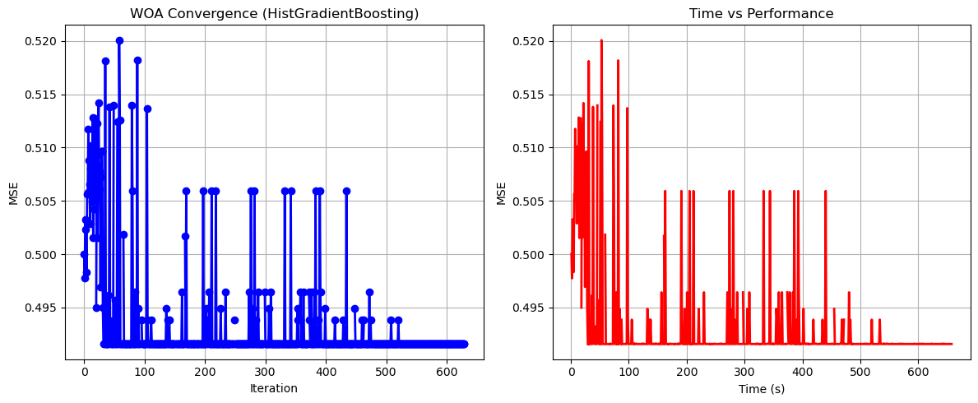

Whale Optimization completed successfully with MSE: 0.4916

==================================================

Running Squid Game Optimizer with HistGradientBoosting...

==================================================

==================================================

=== SQUID GAME OPTIMIZER (SGO) ===

==================================================

[Initialization]

- Players: 30 (15 offensive, 15 defensive)

- Max games: 20

- Search space: 14 features

- Target: Minimize MSE using HistGradientBoosting

==================================================

=== OPTIMIZATION RESULTS ===

==================================================

▶ Best MSE achieved: 0.491608

▶ Time elapsed: 648.38 seconds

▶ Features selected: 13/14 (7.1% reduction)

▶ Selected features:

1. 0

2. 1

3. 2

4. 3

5. 4

6. 5

7. 6

8. 8

9. 9

10. 10

11. 11

12. 12

13. 13

▶ Convergence progress:

- Initial MSE: 0.4942

- Final MSE: 0.4916

- Improvement: 0.5%

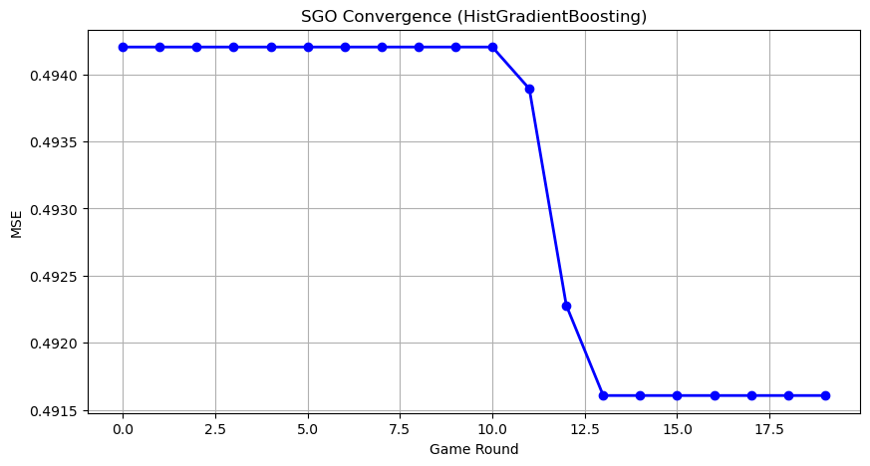

Squid Game Optimizer completed successfully with MSE: 0.4916

==================================================

Running PSH-Hyptrite with HistGradientBoosting...

==================================================

==================================================

=== PSH-HYPTRITE OPTIMIZATION ===

==================================================

[Initialization]

- Search points: 30

- Max iterations: 20

- Initial radius: 0.5 (adaptive)

- Hypersphere samples: 3 per point

- Search space: 14 features

- Target: Minimize MSE using HistGradientBoosting

[Optimization Progress]

Iter 20/20 | Best MSE: 0.491608 | Radius: 0.0250

==================================================

=== OPTIMIZATION RESULTS ===

==================================================

▶ Best MSE achieved: 0.491608

▶ Time elapsed: 1872.52 seconds

▶ Features selected: 13/14 (7.1% reduction)

▶ Selected features (with weights):

1. 0 (weight: 0.724)

2. 1 (weight: 0.749)

3. 2 (weight: 0.949)

4. 3 (weight: 0.777)

5. 4 (weight: 0.674)

6. 5 (weight: 0.957)

7. 6 (weight: 0.754)

8. 8 (weight: 0.510)

9. 9 (weight: 0.780)

10. 10 (weight: 0.579)

11. 11 (weight: 0.929)

12. 12 (weight: 0.631)

13. 13 (weight: 1.000)

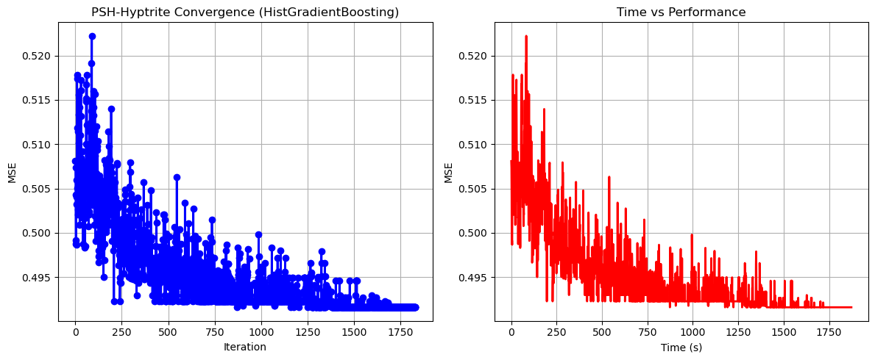

PSH-Hyptrite completed successfully with MSE: 0.4916

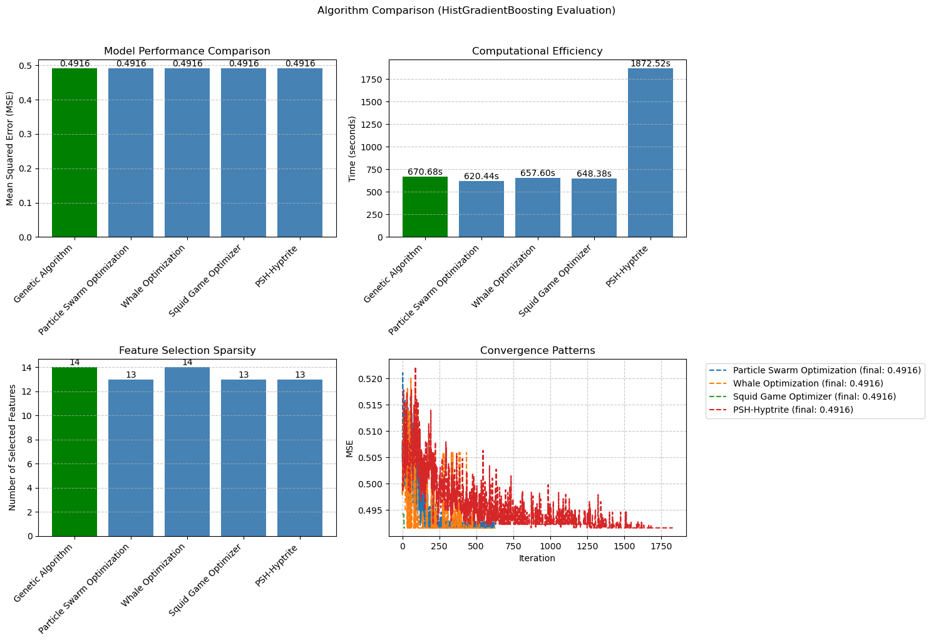

============================================================

=== FINAL FEATURE SELECTION RESULTS USING HistGradientBoosting ===

============================================================

🏆 BEST ALGORITHM: GENETIC ALGORITHM

• MSE: 0.491578

• Time: 670.68 seconds

• Features: 14/14 (0.0% reduction)

📊 COMPARISON TABLE:

Algorithm MSE Time (s) Features

---------------------------------------------------------------------------

Genetic Algorithm 0.491578 670.68 14

Whale Optimization 0.491578 657.60 14

Particle Swarm Optimization 0.491608 620.44 13

Squid Game Optimizer 0.491608 648.38 13

PSH-Hyptrite 0.491608 1872.52 13

🔍 SELECTED FEATURES:

1. 0

2. 1

3. 2

4. 3

5. 4

6. 5

7. 6

8. 7

9. 8

10. 9

11. 10

12. 11

13. 12

14. 13

💡 Tip: Consider feature importance from HistGradientBoosting for further analysis